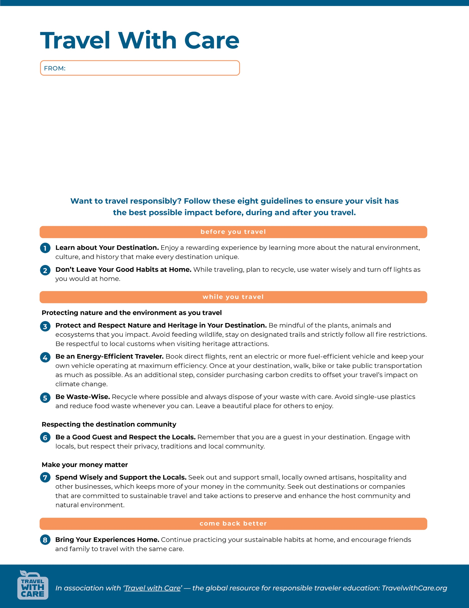

Your Organization’s Name Here